CUSTOMER SUPPORT TICKET PRIORITY PREDICTION AND AUTOMATED ASSIGNMENT SYSTEM USING AGENTFORCE
COLLEGE NAME:
UNIVERSITY COLLEGE OF ENGINEERING THIRUKKUVALAI
COLLEGE CODE:
8222
TEAM MEMBERS:
UMADEVI K (TEAM LEAD)
NIVETHA K
ANUSHYA N
ASHVATHIKA G
EMAIL ID:
UMADEVI - kumaravel19792008@gmail.com
NIVETHA - nivethak5306@gmail.com
ANUSHYA - anushyaanu275@gmail.com
ASHVATHIKA - ganesanraj864@gmail.com
NM ID:
UMADEVI - CEAF90492799EB2B1694ACA77D78A9904
NIVETHA - cdf9b7e87f4b36d98b84a2df115f5812
ANUSHYA - 840BB77D9FA64F9BDE14D6F6C688DDA4
ASHVATHIKA - ABF910A99C15578B37349C92B4D04F41
TEAM LEAD PROFILE LINK:
https://trailhead.salesforce.com/content/learn/trails/become-an-agentblazer-champion-2026

1. Problem Statement
Customer support teams receive a large number of tickets every day. Most of the time, the priority of each ticket is decided manually by support staff, which is slow and depends on individual judgement. Urgent issues may be treated as normal ones and wait in the queue, while minor issues may take the time of experienced agents. Tickets are also assigned manually, which causes delays, uneven workload and a higher risk of missing the Service Level Agreement (SLA). There is a need for an intelligent system that can understand a ticket, predict its priority and assign it to the right person automatically.

2. Objective
- To design a custom Support Ticket Intelligence object in Salesforce to store ticket details.
- To predict the priority (High, Medium or Low) of a ticket by analysing its description.
- To automate ticket assignment and task creation for high priority tickets using Salesforce Flow.
- To reduce the SLA breach risk and the resolution time of tickets.
- To provide an Agentforce agent that answers questions about tickets in natural language.

3. Challenges
- Manual priority decisions are inconsistent and differ from one agent to another.
- Ticket descriptions are written in free text, so identifying urgency from them is difficult.
- High priority tickets get delayed when assignment is done manually.
- Uneven distribution of tickets leads to overloaded agents and missed SLAs.
- Configuring the flow logic, field relationships and agent actions correctly in Salesforce requires careful testing.

4. Solution Approach
The solution is built on the Salesforce platform using a custom object, an autolaunched Flow and an Agentforce agent.
- A custom object named Support Ticket Intelligence is created with fields such as Issue Type, Description, Priority Level, Status, Resolution Time (hrs) and SLA Breach Risk.
- An autolaunched flow, Support_Ticket_Intelligence, retrieves the Account and the Ticket records and stores their Ids in variables.
- A Decision element named Analyze Description checks the ticket description and sends the ticket to the High, Medium or Low priority path.
- On the High priority path, the flow creates a Task, sets the assigned agent and prepares the final message. Medium and Low paths set their respective final messages.
- The Coral Cloud Agent and Guest Agent in Agentforce Studio use the flow so that users can ask for ticket details and get the owner, priority, status, SLA breach risk and resolution time.

5. Milestone 1 – Salesforce Account
A Salesforce Developer Edition org (Coral Cloud Resort) was created and the Setup Home page was opened after login. This is the starting point for creating the object, the flow and the agent.
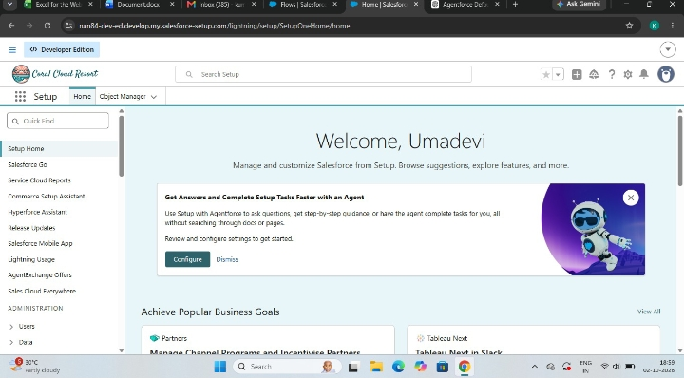
Figure 1: Salesforce Setup Home page after login

6. Milestone 2 – Objects Creation
A custom object named Support Ticket Intelligence was created to store the support tickets. It contains 14 fields, including Description, Issue Type, Priority Level, Resolution Time (hrs), SLA Breach Risk, Status and the auto-numbered Ticket Number.
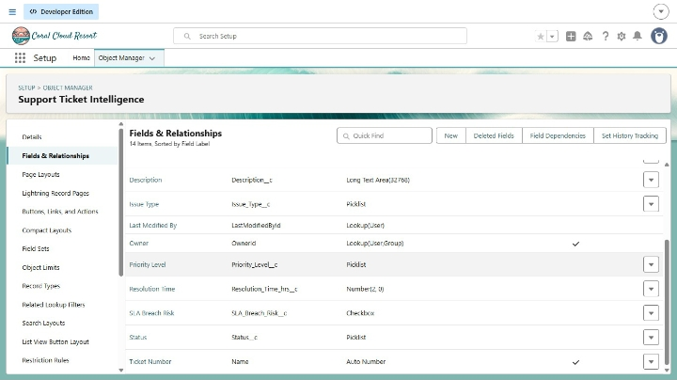
Figure 2: Fields and Relationships of Support Ticket Intelligence

7. Milestone 3 – Creating a Tab for Support Ticket Intelligence Object
A custom tab was created for the Support Ticket Intelligence object and added to the Sales app navigation, so that users can open the ticket records directly.
After the tab was created, the autolaunched flow Support_Ticket_Intelligence was built to analyse each ticket. It starts by getting the Account and the Ticket records and storing their Ids.
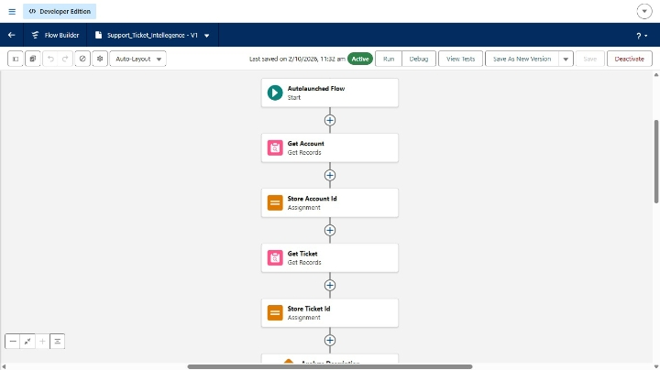
Figure 3: Start of the Support_Ticket_Intelligence flow
The Analyze Description decision element splits the flow into High, Medium and Low priority paths.
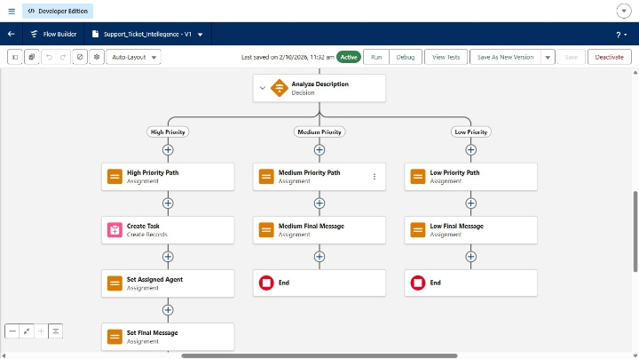
Figure 4: Decision element with High, Medium and Low priority paths
The High priority path creates a task, sets the assigned agent and the final message before ending. The Medium and Low paths set their final messages and end.
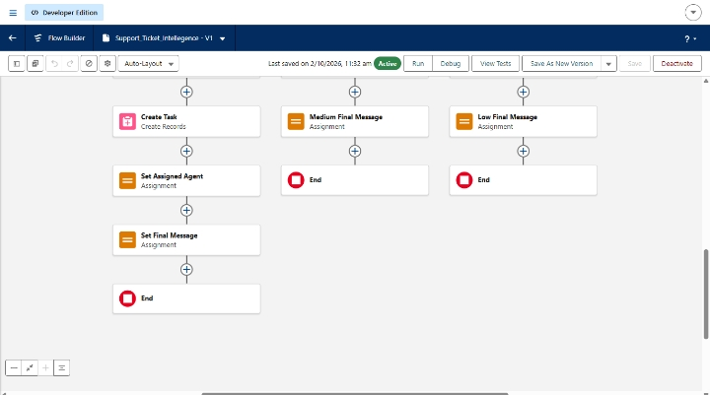
Figure 5: Task creation and assignment in the High priority path
The Agentforce Agents page lists the Coral Cloud Agent, Customer Service Agent, General Agent and Guest Agent, all active.
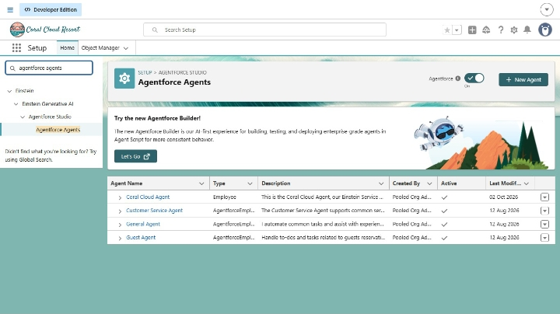
Figure 6: Agentforce Agents list in Agentforce Studio
Finally, the Coral Cloud Agent, an Employee type Einstein Service Agent (Version 1, active), can be opened in the Agentforce Builder using the Open in Builder button.
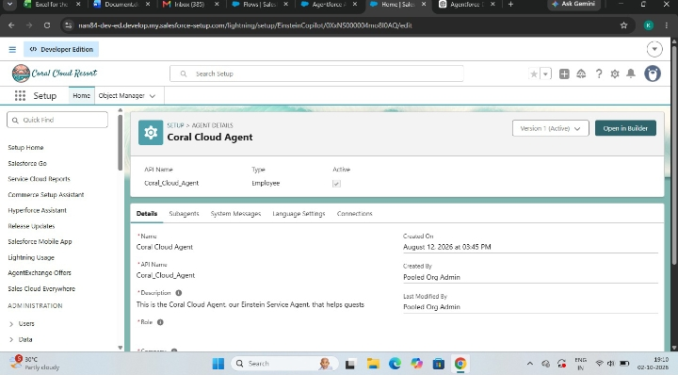
Figure 7: Coral Cloud Agent details with the Open in Builder option
Final outcome: the Support Ticket Intelligence tab shows the ticket TKT-0001 with its Customer, Contact, Issue Type, Priority Level and Status, and the Guest Agent returns the ticket details such as owner, priority, SLA breach risk and resolution time.
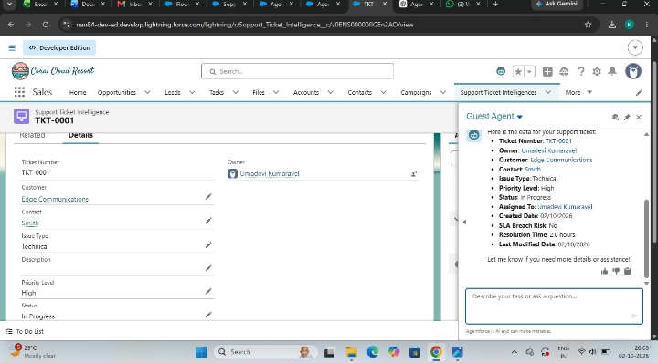
Figure 8: Final output – Support Ticket Intelligence tab and Guest Agent response for TKT-0001

8. Functional and Performance Testing
Functional testing was carried out to confirm that every part of the system works as expected. Performance was checked by observing how quickly the flow and the agent respond.
Test Case | Input / Action | Expected Result | Status
Ticket creation | Create a ticket with Issue Type, Description and Status | Record saved with auto number (TKT-0001) | Pass
Priority detection | Description analysed by the flow Decision element | Ticket routed to High, Medium or Low path | Pass
High priority handling | High priority ticket submitted | Task created and agent assigned automatically | Pass
Agent response | Ask the Agentforce agent for ticket details | Agent returns owner, priority, status, SLA risk and resolution time | Pass
SLA breach risk | Check SLA Breach Risk field | Checkbox shows correct value for the ticket | Pass

Performance observations: the flow runs immediately when a ticket is created, the agent responds to a query within a few seconds, and a ticket such as TKT-0001 with High priority shows a resolution time of 2.0 hours with no SLA breach risk.

9. Advantages and Disadvantages
Advantages
- Tickets are prioritised automatically, so urgent issues are handled first.
- Assignment is automatic, which saves time and balances the workload.
- Lower SLA breach risk and faster resolution time.
- Users can get ticket details in plain language through the Agentforce agent.
- Built with Salesforce clicks-not-code tools, so it is easy to maintain and extend.
Disadvantages
- The priority decision depends on the rules written in the flow, so it may miss unusual descriptions.
- Needs a Salesforce licence with Agentforce, which has a cost for large organisations.
- Agent responses can sometimes be wrong, so important details should be verified.
- Regular updates to the rules are needed as new types of issues appear.

10. Conclusion
The project shows how Salesforce Flow and Agentforce can be combined to make customer support faster and more reliable. Tickets are stored in a custom object, their priority is identified from the description, high priority tickets are assigned automatically with a task, and users can ask the agent for ticket details at any time. The system reduces manual work, improves response time and helps the support team meet its SLAs.

11. Future Scope
- Use machine learning or Einstein prediction models to predict priority more accurately instead of fixed rules.
- Assign tickets using agent skills, availability and current workload.
- Send automatic email, SMS or WhatsApp notifications to customers and agents.
- Build dashboards and reports for ticket trends, SLA performance and agent productivity.
- Support multiple languages and voice-based ticket creation.
- Integrate with other channels such as chat, social media and phone.

12. Appendix
A. Main Salesforce Components
Component | Purpose
Support_Ticket_Intelligence__c | Custom object that stores support ticket information.
Ticket Number (Name) | Auto number field that gives each ticket a unique number (TKT-0001).
Issue Type | Picklist field that stores the type of the issue (for example, Technical).
Description | Long text field that stores the ticket description analysed by the flow.
Priority Level | Picklist field that stores the priority (High, Medium or Low).
Status | Picklist field that stores the ticket status (for example, In Progress).
Resolution Time (hrs) | Number field that stores the time taken to resolve the ticket.
SLA Breach Risk | Checkbox field that shows whether the ticket may breach the SLA.
Support Ticket Intelligence Tab | Custom tab that gives direct access to ticket records.
Support_Ticket_Intelligence Flow | Autolaunched flow that analyses the ticket and decides the priority path.
Analyze Description (Decision) | Splits the flow into High, Medium and Low priority paths.
Create Task | Creates a task for High priority tickets.
Coral Cloud Agent | Einstein Service Agent that helps users with ticket queries.
Guest Agent | Agentforce agent that returns ticket details to users.
B. Team Implementation Checklist
Milestone | Completion Check
Milestone 1 | Salesforce Developer Edition account created and login verified.
Milestone 2 | Support Ticket Intelligence object and its fields created.
Milestone 3 | Tab created and added to the app; flow and agent configured.
Final | Functional testing done and evidence/screenshots collected.
C. Team Members
Name | Role
Umadevi K | Team Lead
Nivetha K | Member
Anushya N | Member
Ashvathika G | Member

